Case 8-A482-US-AK-Tlingit-Sun Crest-Blue-eyed-1960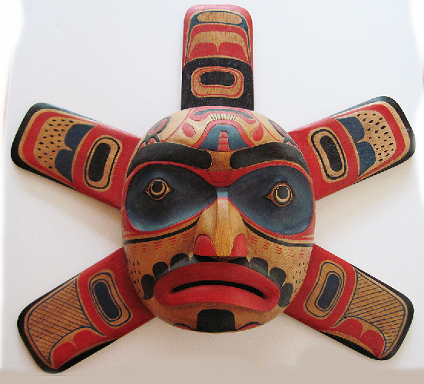

**Fig. 1.** US-AK-Tlingit-Sun Crest-Blue-eyed-1960

**Case no.: 8**

**Accession Number: A482**

**Formal Label:** US-AK-Tlingit-Sun Crest-Blue-eyed-1960**Display Description:**

Meaning:  Sun radiates sunlight, warmth, and healing powers. This blue-eyed version of a Sun Crest may indicate diminished (blue) sunlight made by a partial or full solar eclipse. The red-eyed version of a Sun Crest is presumed to indicate regular sunlight. The Sun Crest is “owned” by three Tlingit tribes

1). SHTAX’HÉEN KWÁAN: Wrangell Bitter Water Tribe, Raven Moiety, Kiks.ádi Gagaan Hít (Sun House), at Wrangell, AK: 56º28'15" N 132º22'36" W.

2). SHEEY AT‘IKÁ (a.k.a. SHEET’KÁ) KWÁAN: Sitka Outside Edge of a Branch Tribe, Raven Moiety, Gagaan Hít (Sun House), at Sitka, AK: 57º03'11" N 135º19'48" W.

3). JILKOOT KWÁAN: Haines Chilkoot Tribe , Wolf/Eagle Moiety, Shangukeidí Kaawdliyaayi Hít (House Lowered from the Sun) at Haines, AK: 59°08'21.21" N -135°00'0.00" W.

**Date or Time Horizon:** 1960

**Geographical Area:** SE Alaska

**Map, GPS coordinates:**



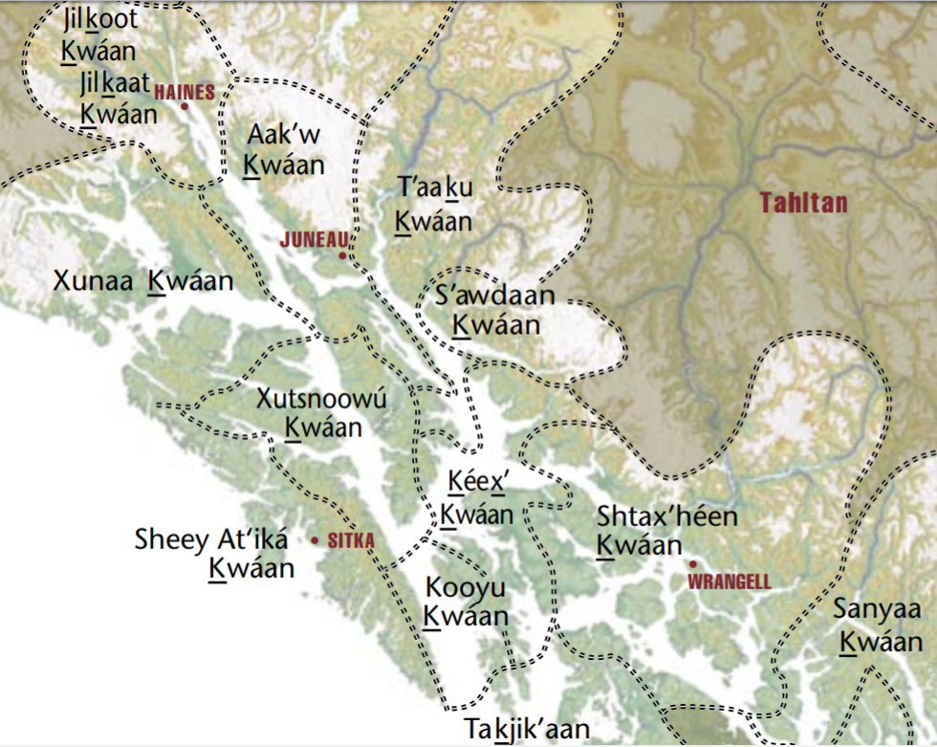

Map of Sun Crest Tribal Locations, Pacific Northwest. From http://www.cherrygallery.com/journal/wp-content/uploads/2015/03/Tlingitgroups.jpg

**Cultural Affiliation:** Tlingit

**Media:** cedar; red black, dark blue paint.

**Dimensions: H** 38.735 cm, 15.25 in; W 45.72 cm, 18 in

**Weight: 659 gm, 1 lb 3 5/8 oz**

**Condition: original.**

**Provenance:** artist

**Discussion:**

Legend (retold by R. J. Coffman, Jr. 2017): Long ago Raven was pure white, like fresh snow. He lived high in the mountains. Below in the valley “the People” were camped in wigwams. There an avaricious Chief coveted elaborately carved cedar boxes in his wigwam, which confined Stars, Moon, and Sun under lock and key. The only light Raven could see from his high mountain nest came from “The People’s” campfires. Raven flew down to the valley following these campfires and found the Chief’s wigwam. Quickly Raven transformed himself into the shape of the Chief’s baby grandson and hid the baby out of sight under some blankets. Then Raven cried and cried like a human baby for the beautiful boxes to be opened. Out of desperation the Chief opened the boxes one by one. He first opened the one with Stars and released starlight. Sky glimmered with millions of tiny stars in the night but Day was still dark. Then he opened the one with Moon and released moonlight. Now Night was brighter when Moon was full, but then Stars were outshone. During the daytime when Moon was full there was an eerie glow of Moon in the sky. But, it still was not daylight. At night only when Moon was darker were Stars more visible. Things were still not right. So Raven kept crying. Finally, the Chief slowly opened the cedar box with Sun. Raven had been able to maintain his shape as a human baby until this point, but it had been difficult because he wanted his raven shape back. Then Sun Chief fully opened the box with Sun and Earth was flooded with sunlight. Raven was so joyful he stopped crying like a baby and in a split second his shape transformed into a raven. Sun Chief immediately recognized him and was furious with his deceit. First, he found his baby grandson under the blankets. Then, he captured Raven who could not fly out of the wigwam because the flap was tied shut. The Chief crammed him into the box that had held Sun. While the Chief was busy with his grandson and untied the flap of the wigwam to take the baby into the sunlight, Raven was able to silently squeeze himself through the small smoke-hole at the top of the cedar box with much difficulty. He was able to escape through the opened wigwam door, and now he could fly to his high mountain home in the light of the Sun.

That's why ravens are now black-as-a-smoke-hole instead of pure white, like fresh snow and why they like to live in high mountains so they can keep watch on “the People” below.

**References:**

1. Unpublished “genealogical papers,” by Louis Shotridge (N.D.)

2. The unpublished manuscript: “History of Tlingit Tribes and Clans, by George Emmons (N.D.)

3. The unpublished list of “Tlingit Tribe, Clan, and House Group Names,” by Jeff Leer (1985)

4. Social Structure and Social Life of the Tlingit Alaskan, by Ronald Olson (1976)

5. Social Conditions, Beliefs, and Linguistic Relationship of the Tlingit Indians, by John Swanton (1970)

6. An unpublished list of Angoon clan houses by Lydia George (1967)

7. My Old People Say, by Catherine McClellan (1975)